Hospital Management System

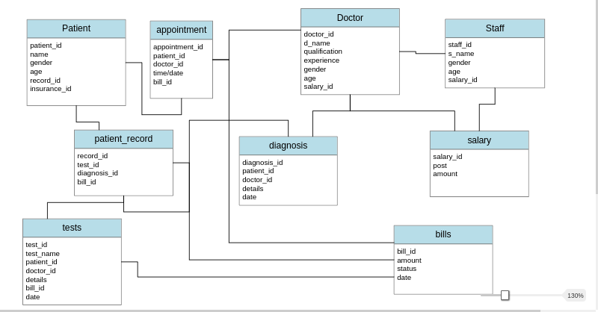
Our project Hospital Management system includes registration of patients, storing their details into the system, and also booking their appointments with doctors. Every patient, doctor and staff has a unique id’s. Patient can search availability of a doctor and vice versa can be done by the doctors to check the details of a patient using the ptient_id.

This application has mainly three type of users:

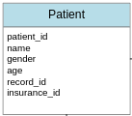

Patients: Can register own his own book appointments with the doctors on available time slots. Have primary key as patient_id and forign key as record_id which has to be unique

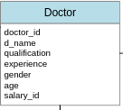
Doctors:Have primary key as doctor_id can have/assign staff can access patient record priscribe test make diagnosis have a unique salary_id which is forign key
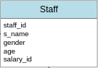

Staff:Have primary key as staff_id can can access patient record and report test results have a unique salary_id

Other tables:
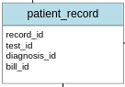

patient record :has record of all the history ,list of test ,diagnosis changes in data of the patients record id is the primary key of this table and has various forign key like test id diagnosis id bill id this table can be accessed by all the actors patient can view his record were as staff and doctor can update the record as well as read them
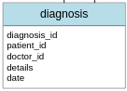

Diagnosis:has diagnosis id as primary key ,patient id and doctors id are the forignj key but the patient id has to be unique as one diagnosis can not be for more than one patient .the patiet record has the diagnosis id so that it can access the diagnosis of the patient.

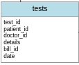

Test:has test id as primary key has patient id and dotor id as forign key also has a unique bill id

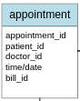

Appointment:has appointment id as primary key Hs patient id and doctor id as forign keys and bill id as unique key only patient can book appoitments has access to doctors free slots to book appointment.

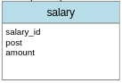

Salary: doctors and staff needs to get paid salaryis the record of all their salary with salary id as the primary key which is also the forign key t.the amount is the sum of their monthly salary.
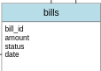

Bills:it has record of all the bills of the user ie patient and has record of the payment ,it has bill id as the primary key and some other details related to the bill generation.

